Name :M Sushmitha

Class: 111- ECE

IBM I’d : au621421106053

Reg no :621421106053

## Smart IoT Flood Monitoring System

**Abstract.** Flood is one of the natural disasters that cannot be avoided. It happens too fast and affected so many lives and properties. Before this, most of the existing system that has been developed are only focus on certain areas. Other than that, majority of the public cannot monitor and have no idea when the flood going to be happened since they do not have any information and data about the weather condition. By having Smart IoT Flood Monitoring System, this will solve all the drawbacks of the existing system. The proposed system is suitable for cities and village areas. Furthermore, if the public has an internet access, they can monitor what is happening and predict if there is any upcoming flood at the web server. The proposed system is a low cost in design and easy for maintenance. This project will update the water level at the web server and the system will issue an alert signal to the citizens for evacuation so that fast necessary actions can be taken.

Introduction

Flood is tremendously dangerous and has tendency to blow the whole city and area of houses away. Flood also can cause huge property damage and loss of life. It is a natural disaster where dry land suddenly submerged under water. Some floods can happen out of sudden and very fast. When a flood occurred, water will bring along and destroy things like houses, vehicles and variety of dangerous objects such as

sharp wood that can cause someone hurt. Some have been hit by with the swirling things. It is necessary to have early warning system that will warn the residents about the risk and threats when there is upcoming flood.

There are numerous technologies available to anticipate and avoid. It is truly believed that most of the citizens have tablets and smartphones at their fingertips. The smart IOT flood monitoring system plays big roles during the flooding where the high effective system will help government and society to manage situation of flood victims efficiently and hence, reduce the disaster effect.

It is very important to make this system simpler, easy to be operated; cost effective system and most importantly is to effectively alert society as earlier as possible. The proposed system will provide simple and basic monitoring interface, sufficient data on flood level, and future short-term water level prediction.

#### **2. Literature Review**

According to previous related works, there are several methods used to develop the system. Based on this research paper[2]the web based IoT ‘Thingspeak’ platform is used which has an open API service that store and retrieve the data from the sensor and the sensed data output is displayed in graphical form. In this project, sensors are used to implement the IoT Operation for sensing and monitoring the heat, humidity, temperature, light intensity, rain sensing, air quality, barometric pressure and sea level pressure of the surroundings. Figure 1 shows ThingSpeak platform.

A picture containing sky, outdoor

Description generated with high confidence

#### Figure 1: ThingSpeak IoT Cloud Website [3]

Then, the proposed system in [4], an Arduino was used to control the entire system. It is interfaced to GSM modem and pressure sensor. The pressure sensor is used to measure the water level and the Arduino is used to calculate the height value of the water using Pascal’s Law. The level of water is calculated then will be equated with the threshold value that have been set. If the water level is exceeded than the threshold value, the microcontroller will alert the residence by sending SMS.

Arduino family have their own pros and cons features. For the Arduino family, they are all almost slow with small memories and limited functionality meanwhile the Mbed platform uses ARM Cortex microcontroller which are generally have more memory spaces, much faster and more functionality. Therefore, any projects that require more memory or processing speed are recommended to use ARM platform. Figure 2 shows ARM Mbed LPC1768 microcontroller.

A circuit board

Description generated with very high confidence

#### Figure 2: ARM Mbed NXP LPC1768 Microcontroller

##### 3. Methodology

Methodology discusses about the approaches used to collect the data input and decision making to the public. Some improvement is needed to develop a Smart IoT Flood Monitoring System. This will focus on the system that uses the electronic based components for this project. The planning flow of this project will be explained in details.

###### 3.1 Block Diagram

From the block diagram in Figure 2, Ultrasonic HC-SR04 module sensor will be used to detect the water level of river. The mbed NXP LPC1768 is a microcontroller that will collect all the data in this system. Buzzer will act as an alarm to alert the public and authority when there is upcoming flood and data will be updated to web server. The function of LCD and LED are to display and indicate the level of water.

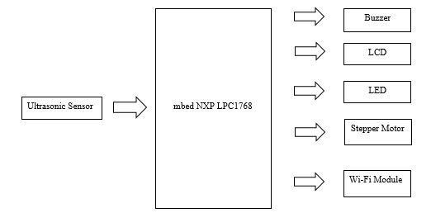

Figure 3: Block diagram Smart IoT Flood Monitoring System

###### 3.2 Flow Chart

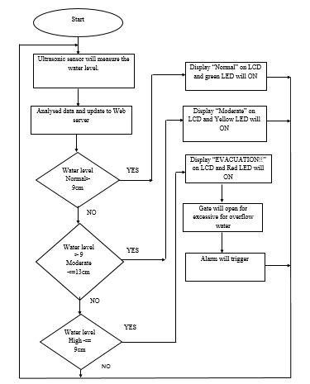

#### Figure 4: Flowchart of the System

Based on flowchart in Figure 4, Smart IoT Flood Monitoring System is developed to alert the public closest to the area when there is upcoming flood. The process is starting when ultrasonic sensor measures level of water in the river. The collected data from the sensor are gathered and will be forwarded to microcontroller and data will be displayed at web server. Then, data will be analysed and compared. As a user, he/she can control the stepper motor and buzzer wirelessly. Flood status dangerous will be determined based on that collected data. Thus, water level status will display on LCD and web server. LED will be turn on to indicate the water level. Furthermore, the stepper motor will be turn on for the passage of excessive flood when it reached at the highest threshold value and the alarm will be triggered immediately to alert the public. Hence, the citizens will be well prepared for evacuation before the flood occurred.

##### 3.3 ARM Mbed

Arm Mbed IoT device platform offers the operating system, and many cloud services. based Internet of Things (IoT) solutions. Mbed LPC1768 and application board was used as the microcontroller in the Smart IoT Flood Monitoring System. It is the LPC176x family of microcontrollers. It also drag and drop programming, with the board represented as a USB drive and easy to use online tools.

##### 3.4 Hardware Design Implementation

Figure 5 shows the circuit diagram and each component connect each other. The ultrasonic sensor, stepper motor, Wi-Fi module, LED, LCD, buzzer is connected to ARM microcontroller. Ultrasonic sensor and stepper motor need at minimum 5V. to generate data meanwhile Wi-Fi module requires 3.3v only. The stepper motor interface with ARM microcontroller through driver module that connected to PWM pin. Other than that, the ESP8266 Wi-Fi module interface with SPI RX and TX pin interface.

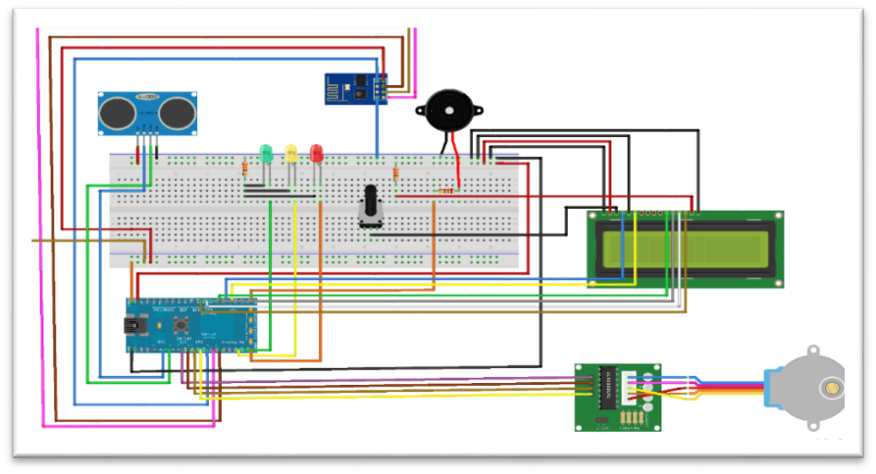

#### Figure 5: circuit connection of the hardware

##### 4. Result

Firstly, new Wi-Fi SSID and PASSWORD must be setup. Then, need to check if the Wi-Fi setup is working successfully. If the setup is success, it will get a valid IP address from a Wi-Fi router SSID and PASSWORD that have been set up. After WiFi setup gets a correct IP address = 172.20.10.13, we make that IP address in the terminal application communicate to ESP8266 WiFi module. The browser does not have Domain Name System (DNS) because we need to pay for a registered domain. To control ARM wirelessly, it must be connected to the server which the server has it own IP address. So, when it connects to the server through that IP address, the server detect that user want to connect, it will reply with the web server.

and buzzer.

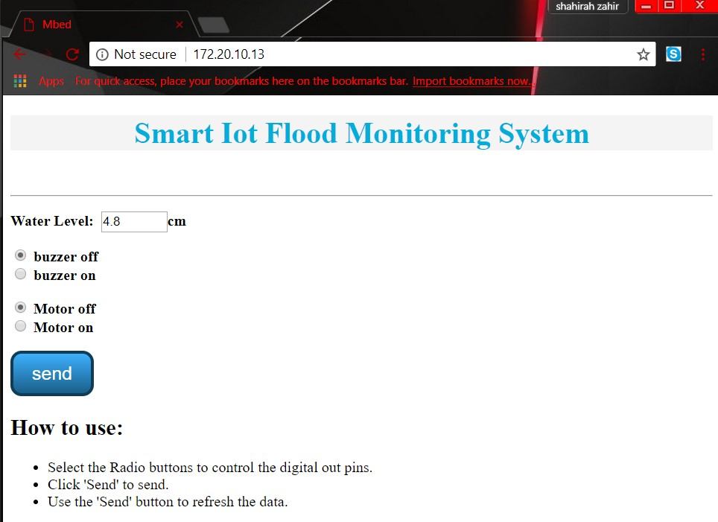

Figure 6: Smart IoT Flood Monitoring System Web Server

As shows in figure 7, this system is using ARM microcontroller board. This circuit is consisting of several hardware components which includes of ARM board, ultrasonic sensor, ESP8266 Wi-Fi module, stepper motor, stepper motor module, buzzer, LCD, LED breadboard, resistors, potentiometer, and some jumper wires as connection for whole circuit.

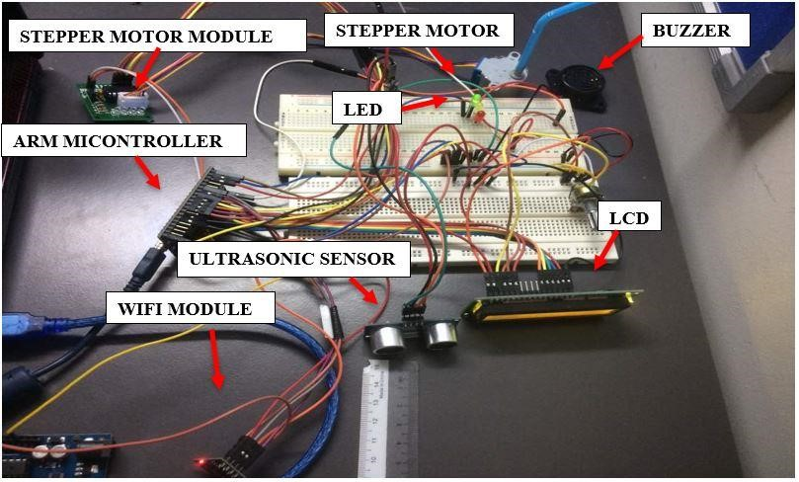

Figure 7: Complete circuit of Smart IoT Flood Monitoring System

##### 5. Conclusion

Nowadays the Internet Of things (IoT) is broadly used in worldwide, this system will display the data of the water level measured on web server. If there is continuous heavy rain, user can simply monitor the water level through laptop or mobile phone wherever they are as long there is an internet connection. At the same time, this smart system can also control the alert signal and the gate to let the excessive water flows wirelessly. The system can be more enhanced by sending SMS as warning signal to citizens for those did not subscribe mobile data or did not have any internet connection.